CAMP PARENT’S GUIDE

YMCA CAMP WENONAH

Table of Contents
GREETINGS! 3
About the Winona Family YMCA Camp Wenonah 4
Mission Statement 4
YMCA Values and Character Development 4
The YMCA Camp Wenonah Staff 4
CAMP SCHEDULE 5
DROP OFF AND PICK UP 5
DAILY SCHEDULE 6
SCHEDULE OF THE WEEK 6
PACKING LIST 7
PROGRAM INFORMATION 8
COMMUNICATION 8
EMERGENCY PLAN 10
CAMP POLICIES 10
For a successful camp experience… 11

GREETINGS!

Welcome to the Winona Family YMCA’s Camp Wenonah and thank you so much for registering your child for our summer programming! We’re looking forward to sharing the outdoors with them this summer, helping your child explore nature in a safe and nurturing environment. We have created this Parent Guide as a reference for parents to best prepare their camper for a week at Camp Wenonah. The guide can be used as a quick reference, but we recommend that you spend some time to familiarize yourself with our policies. As always, please don’t hesitate to contact us if you have any further questions. We look forward to seeing you this summer!

About the Winona Family YMCA Camp Wenonah

Mission Statement

Camp Wenonah seeks to provide a safe space for youth and adults to explore and grow a passion for the outdoors through programming that focuses on environmental education, challenge by choice philosophy, and teamwork and collaboration. Through programming and events, Camp Wenonah seeks to be an inclusive and welcoming space for all to learn, grow, and thrive in the outdoors.

YMCA Values and Character Development

It is important to us that campers have fun and learn new skills when they come to camp. Even more important, however, are our efforts to provide campers with experiences that support their growth and help them develop the relationship, leadership, and decision-making skills that will help them to be happy and successful in the future. At camp, it is our goal to make every activity, from flag-raising to team building initiatives, opportunities for learning and development. The camp staff strives to include the core values of the YMCA: caring, honesty, respect and responsibility to each and every experience that campers have while they are at camp.

The YMCA Camp Wenonah Staff

A great summer at camp begins with great staff! At Camp Wenonah, we strive to offer a balance of creativity, sensitivity, energy, enthusiasm, and experience at camp. Our staff members are mature, responsible, caring, and are committed to youth development.

Counselors are typically college students or graduates who come to us with experience or training in outdoor recreation or leadership, education and a diverse background of skills and talents. Staff members are carefully selected through a rigorous hiring process and complete a thorough training program.

All staff members are First Aid and CPR certified and go through a federal criminal background check. Staff members also have training and certifications in specific program areas and all ropes course activities. Staff training also covers topics such as counseling skills, age-appropriate programming, risk management, homesickness, behavior management, co-habitation with wildlife, emergency procedures, fire prevention and skills training in specific activity areas.

CAMP SCHEDULE

DROP OFF AND PICK UP

DROP OFF
Camp drop off is at Camp Wenonah this summer from 8-9am. It may be helpful to set up carpooling with other families. Please be patient as we work through the drop off process.

PICK UP
Camp pick up is at Camp Wenonah this summer from 4:30-5pm. There will be a late pickup fee after 5:10pm of $5 per child. If you are not picking up your child, make sure you fill out the authorized pick up form to let us know who is alternatively picking them up.

IDENTIFICATION MUST BE PROVIDED DURING PICK UP.

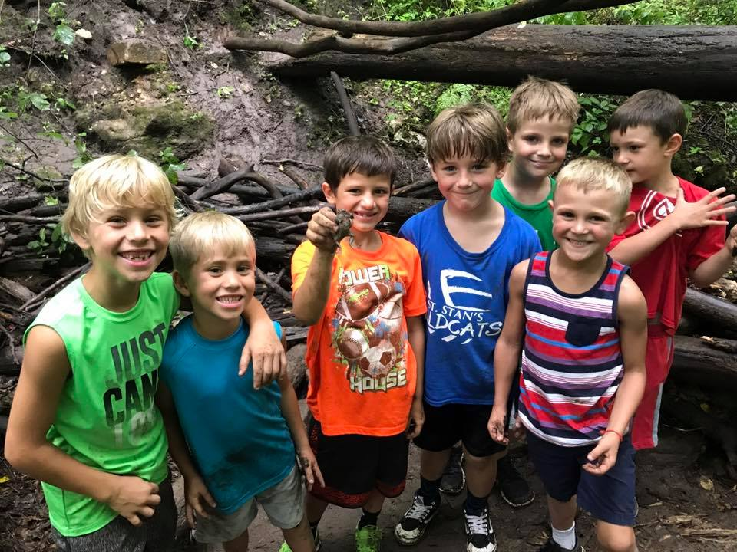

DAILY SCHEDULE
K-8th grade campers can expect a variety of activities throughout the day to keep them engaged during a week at Camp Wenonah. See below for a template of the daily schedule each week.

Schedules are subject to change on a day to day basis.

MONDAY-FRIDAY

- 8:00-9:00am Camp Drop Off

- Camp Daily Start: sunscreen, bugspray, put things away, flag raising, camp rules, songs and skits

- Camp Activities and Games

- Lunch

- Free Time

- Camp Activities and Games

- Snack

- Camp Activities and Games

- 4:00-4:30pm Closing Ceremony: flag lowering, songs and skits

- 4:30-5:00pmCamp Pick Up

SCHEDULE OF THE WEEK
We have planned out certain main activities for specific days. These are subject to change due to weather conditions.

MONDAY: Zip Line

TUESDAY: Group Hike

WEDNESDAY: Low Ropes Course

THURSDAY: Group Hike and Water Activities

FRIDAY: High Ropes Course, Zipline, and Family Night
**Family Night will be 4:00-5:30pm

PACKING LIST

EVERYDAY
Please ensure your camper has the following items each day of camp.

- Sunscreen and Bug spray

- A hat

- Weather appropriate clothing

- Filled water bottle

- Sturdy shoes. MUST be strapped to the foot and closed toe.

- Sandals or water shoes for water activities

- Towel and change of clothes for water activities

- Lunch will be provided. If a camper wants snack they will need to be brought from home for snack time.

PROGRAM INFORMATION

Camp Wenonah Policy Information
Health and Covid-19 Related Policies

PROGRAM DETAILS

CAPACITY
- Each week of camp we will have a maximum capacity of 40 campers.
- Campers will be broken into 4, age alike groups with a maximum of 10 campers in each group with 1 counselor. There will be a lead staff on hand to assist as necessary.

LUNCH SPACES
There will be two separate lunch spaces: the barn and the outdoor pavilion.

PERSONAL BELONGINGS
- All camper groups will have designated spots for their personal things.
- Campers will be required to place all of their personal items inside an individual receptacle.
- No unnecessary personal items will be allowed at camp, including toys, games, or supplies that are not included on the packing list. Please keep these items at home.
- Cell phones will not be permitted at camp. We strongly recommend that cellphones are left at home. If you wish to send your child with a phone, we will ask that they are left in the campers bag with other belongings. The YMCA is not responsible for lost or stolen property.

HEALTH AND SAFETY
Camp Wenonah and the Winona Family YMCA recognize that handwashing is our first line of defense for youth participants in helping limit the spread of germs and bacteria. Camp Wenonah staff will be diligent to discuss with campers the need to wash their hands often and to not touch their faces. Health and Safety will be the highest priority for Camp Wenonah staff as to ensure the Winona Family YMCA is doing their part to limit the spread of Covid-19 and protect camp participants.

LUNCH
All meals will be provided by Hy-vee. If you have special dietary needs, please feel free to bring your own lunch.
- All surfaces will be disinfected at the beginning of each shift and before meal preparation and feedings using CDC and EPA approved products.
- All staff will wash hands before and after meal preparation and feeding.

HEALTH AND SAFETY POLICIES
All existing health and safety policies apply. Please see health and safety policies document for more information.

If children become sick during care, parents will be called within five minutes of discovering that children have fallen ill.
- Parents will be required to pick up their children within 30 minutes of the phone call.
- Sick children will be kept separate from others, in an isolated area that is in sight of YMCA staff.
- All other children will be removed from areas that this child was in throughout the day to provide YMCA staff time to clean and disinfect the space.

POSITIVE CASE PROCEDURES
In the event of a positive case of Covid-19 in the YMCA facility of a program participant or a member, the Winona Family YMCA will follow the Standard Operating Procedure Response to Covid-19, which includes a deep clean of the entire facility and increased communication from the Marketing Department to alert anyone who may have come into close proximity of the person(s) with a positive case.

The Winona Family YMCA will follow the Covid-19 Exposure and Quarantine Guidelines in the event of positive cases for staff, members, or program participants.

COMMUNICATION

TO LEADERSHIP STAFF
Alex Brown, Sport and Camp Director, is available throughout the week with any questions or concerns. He can be reached through the YMCA main phone line at (507) 454-1520, or through email at abrown@winonaymca.org.

Alex will often be at camp during the season, where service may be limited. He will return messages as soon as possible throughout the workday.

ABSENCES
If your camper is unable to make it to camp, it is expected that you call the YMCA or email Alex. If a camper is absent, we will call to confirm the absence.

EXPRESSING CONCERNS
At the YMCA Camp Wenonah, we strive to provide the best possible experience to all of our campers and families. If you have any concerns, please reach out to Alex Brown via email or phone call. He will address all concerns as soon as possible.

At the end of the camp season, surveys will be sent out through email. Please take a chance to report back any feedback about your camper’s experience at camp. Feedback is an invaluable part of our programming as it helps us grow and expand on our services year-to-year.

REPORTING CHILD ABUSE
Anyone who works with children is required by Minnesota State law to report any suspected signs of child abuse or neglect. Some examples are (including, but not limited to) suspected verbal abuse, physical abuse, sexual abuse, lack of basic care in the areas of personal hygiene or nutrition or leaving a child alone or in the care of another child. After a report is made, it is up to the proper authorities to investigate. A report should be seen as a cause for concern, not an accusation. We are not allowed to discuss the situation with the parent before making a report. Please discuss any concerns you may have with camp staff.

EMERGENCY PLAN

SEVERE WEATHER CONDITIONS
All groups will seek shelter immediately and stay there until twenty minutes after the weather clears. Staff are prepared with weather radios or mobile devices that support severe weather alerts.

EXCESSIVE HOT WEATHER
Activities will be provided indoors or in shaded areas outdoors as appropriate. Water is accessible to children at all times and they are encouraged to drink fluids throughout the day.

MEDICAL EMERGENCY
If a medical emergency arises, we will administer first aid and make every effort to contact the parent/guardian. If emergency medical treatment is required, we will contact a doctor, hospital, or call an ambulance depending on the severity of the injury or illness. Please be aware that any medical expenses incurred will be the responsibility of the parent or guardian.

CAMP POLICIES

We are excited to have you join us for what promises to be a great summer. In order to provide the best possible experience for everyone, there are certain policies and rules of camp that you and your child need to know. Our overall goal is to provide a safe and happy environment for each participant. Please read over the following policies and share the appropriate ones with your child.

BEHAVIOR
Camp Wenonah strives to offer a well-rounded program with a wide variety of activities. Camps promote and encourage communication, problem-solving, and positive social interactions between peers and staff. We believe that this helps to create an atmosphere which decreases the amount of behavior concerns that arise and provides a strong support system for children who are having difficulties. When concerns arise, which are beyond the normal range of issues with the children, staff will communicate those concerns to parents. Our goal is then to create a plan with parents and children to ensure that the child acts and behaves more positively with staff and peers. Steps for serious behavior problems may include written reports with behavior contracts, additional positive reinforcement, and counseling with parents to create a plan for change. If behavior problems continue, permanent dis-enrollment may result. Please talk with the camp staff about any questions or concerns regarding the behavior and specific discipline policies concerning your child.

The following are grounds for immediate termination from YMCA programs without refund or credit:

- Behaving in a way that endangers the health and safety of campers and/or staff

- Possession or use of illegal drugs, alcohol, or cigarettes

- Possession or use of fireworks or un-programmed weapons (knives, etc.)

- Destruction of property

- Leaving camp boundaries or property without permission

- Continues inappropriate behavior, i.e. threatening, profane language, not following directions, teasing, and inappropriate sexual behavior

A child will not be allowed to remain in the program if they are potentially dangerous to other children, staff, or themselves, or who continually disrupt the goals created for the group as a whole.

For a successful camp experience…

- Bring sturdy shoes (closed toe).

- Label everything you send to camp with your camper’s name.

- Ensure your camper has all of the pack list items for each day of the week.

- If you’re not sure, ask. We are here to help!

We look forward to seeing you at Camp Wenonah!

WINONA FAMILY YMCA CAMP WENONAH
YMCA Camp Wenonah is licensed to operate under the Winona County Environmental Services Department, Environmental Health Division.

Winona Family YMCA
902 Parks Ave
Winona, MN 55987
P (507) 454-1520
E abrown@winonaymca.org

Camp Wenonah
31903 Camp Drive
Winona, MN 55987

http://www.winonaymca.org

